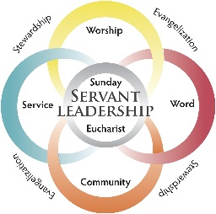 Stewardship Agenda for Meeting #1

Date: Time Location

Meeting Preparation: (For Team Chairperson)
- Bring laptop to show video, set up projector if available, ensure WIFI connection/password prior to start of meeting.
- Read Chapters 1 and 2
- Copies of any documents for all individuals.

Parish Participant Prework
Read Chapters 1 and 2 of Grateful Disciples

*It is vitally important that someone keep a detailed record of the thoughts and ideas generated at each meeting. This recorded information will be essential to completing step four of the process. An easel pad/flip chart can be a great way to do this. Also, please keep your Pastoral Plan (if you have one) readily available to consult.

Prayer: A Steward’s Prayer to the Holy Spirit 5 mins
It can be found on page 63 of Grateful Disciples.
(An alternate prayer may be selected from the 12 Months of Stewardship Resource)

Introductions of Parish Stewardship Team 10 - 15 mins
- Briefly summarize why you said yes to the invitation as team member
- ID chairperson of the Team and the record keeper
- Ensure all contact information is accurate
- Set dates and locations for future meetings

Watch video, Grateful Disciples 15 mins

https://vimeo.com/180808829

Using Meeting Guide #1, discuss Key Themes 15 Mins

Complete and Discuss Worksheet “Time to Reflect: Grateful Disciples as Stewards” 20 - 30 mins

Complete and Discuss Worksheet “Live the Vision: Stewards in Community” 10 - 20 mins
This can be found on page 15 in the Grateful Disciples book.

Discuss homework 5 mins
Participants should read Chapter 3 before Meeting # 2. While reading, participants should be attentive to your parish’s experience and make note of connections or possible needs. In addition, participants should take home the worksheet titled “Taking Stock Stewardship Formation and Communication”.

